How to run the project:

1. Create a db_cems connection on MySql:

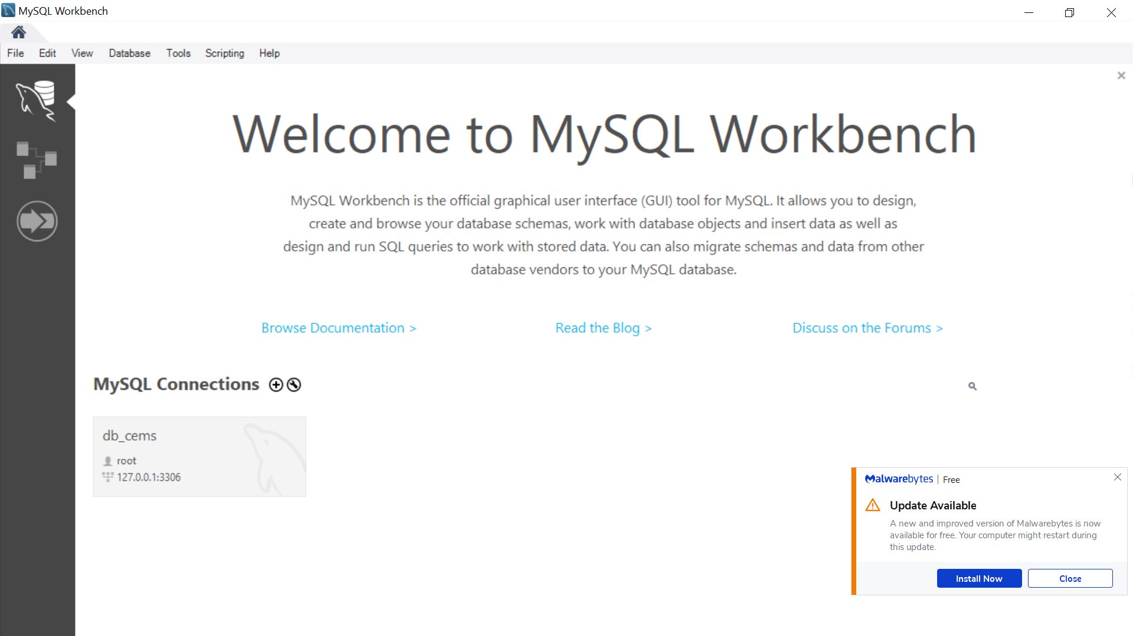

1. Create a db_cems schema:

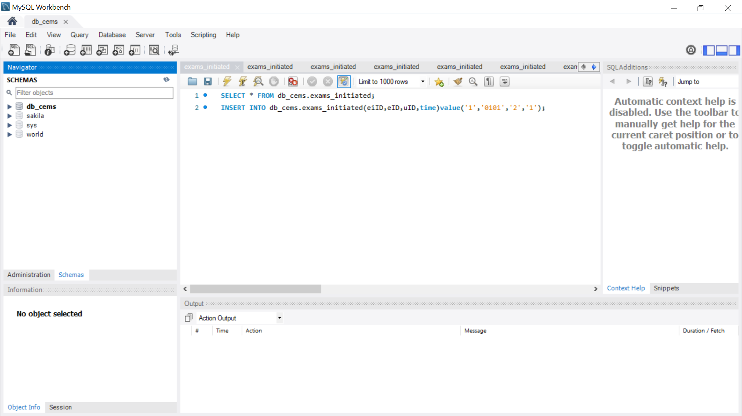



1. Run App_server for the first time and change password to your connection password, then press start server and then build tables:



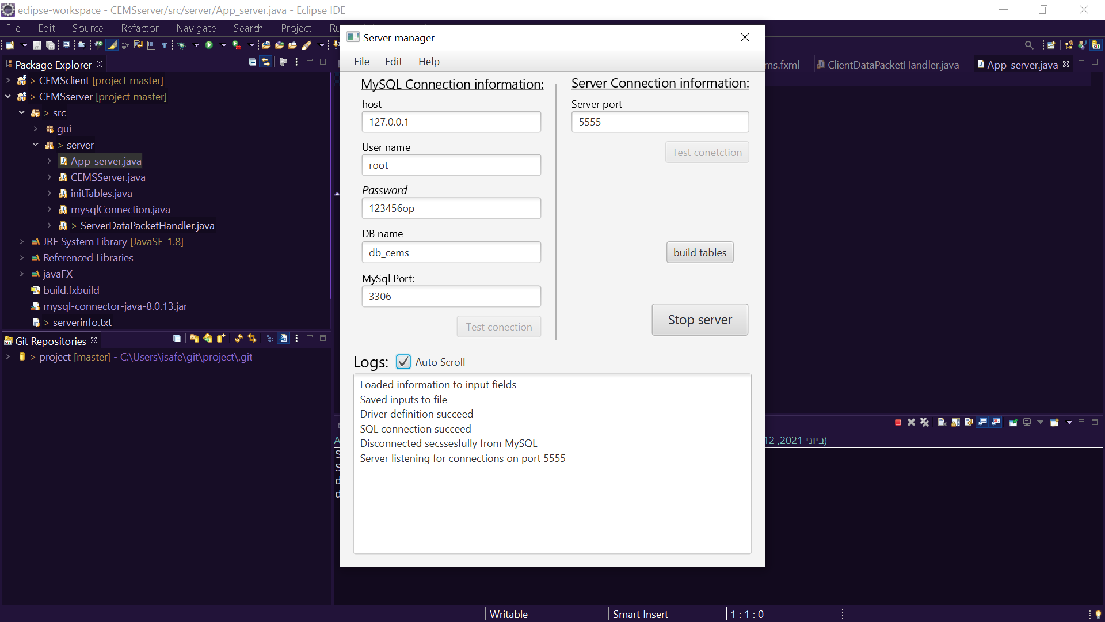

1. Open App_client and enter:

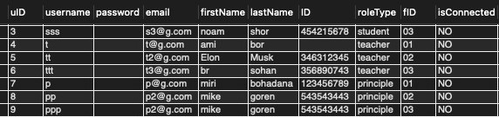

EMPTY PASSWORDS



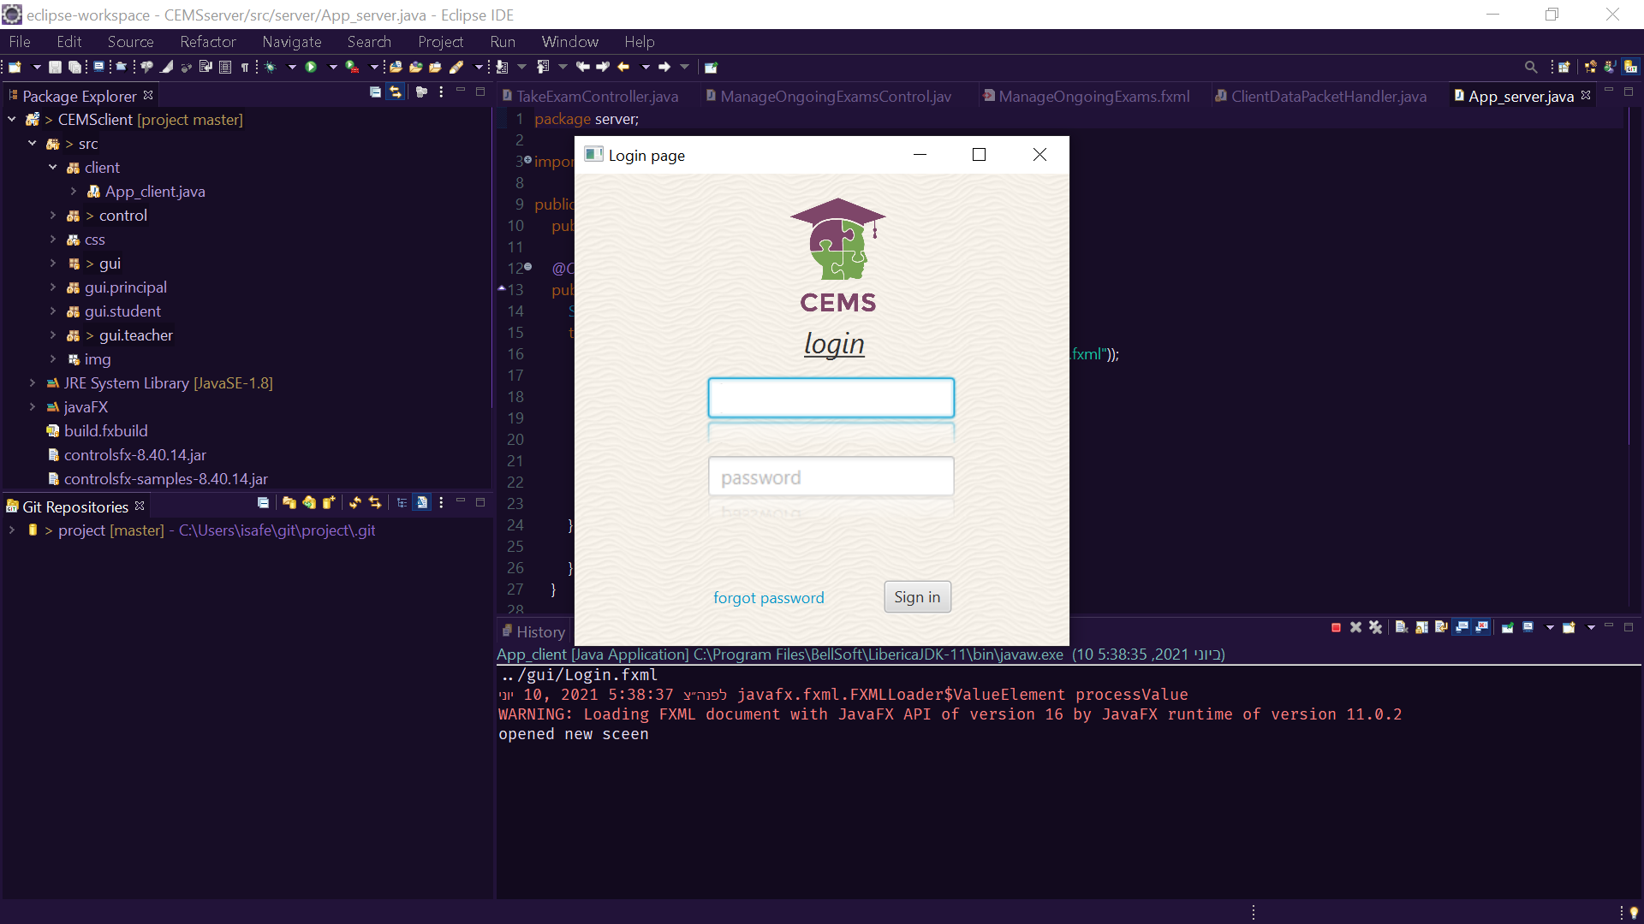

**You can modify the users table via MySQL!**